About 18 months ago I had a lot of new cubs in the Pack and some of them wanted to get their first badge, but weren’t sure about what to do. At the same time I was noticing a lot of the Scout $1 coins in my change, so I decided to try and get everyone collecting coins for a few months.

The results were quite positive with nearly all the Cubs getting their green level collector’s badge – even those that already had the collector’s badge were keen to do this as well.

From a cost perspective, it doesn’t really cost the parents anything, as the coins can simply be returned to the piggy bank at the end (or back to Mum’s purse ☺). I chose to give each Cub one of the Scout $1 coins to start them off – but depending on the size of your pack this may not be viable for everyone

Many of the Cubs had some trouble with finding out the significance of 1966 – this was the year of decimalisation. Prior to 1966 we used pounds, shillings, and pence, so none of our current Australian coins will have a date older than this. I was surprised when preparing this exercise just how many 1966 coins are still in circulation. Most of the Cubs found a coin OK, they just had trouble understanding about pre-decimal money. After most of the Cubs had completed their collections I had an older member of the community come in and talk to them about what it was like changing all the money back in ’66.

The slight difference in the $2 coin from 1988 and 1989 was that these had the artist initials printed on the aboriginal man’s side – after 1989 the initials were removed, but otherwise the image was unchanged.

Since I prepared this, there have been a couple of extra commemorative coins released:-
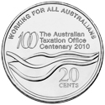 | 2010  Commemorating the Centenary of the Australian Taxation Office.
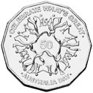 | 2010  Commemorating Australia Day. Designed and sculpted by Vladimir Gottwald.
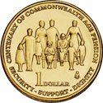 | 2009  100th year of the age pension. Designed and sculpted by Wojciech Pietranik.
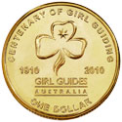 | 2010  Commemorating the centenary of girl guiding in Australia. Designed and sculpted by Wojciech Pietranik.

If there is anything you are unsure about, check out the Royal Mint web site, as this is where I got most of the information to prepare this (http://www.ramint.gov.au/designs/).

Hope you (and others) find this useful,
Aaron Power
CSL 1st Branxton / Greta.

